REPORT ON

TESLA ELECTRIC CARS

**By,**

**R.Sreenivas**

**19PW41**

**M.Sc Software Systems**

20/10/2019

Sreenivas.R

19PW41

PSG College of Technology

Coimbatore-641001

Sir,

I would like to submit a report on TESLA ELECTRIC CARS.This report has been made carefully with genuine data referred from various sources.

The views of the persons got from this report can change from person to person.Any inquiries on this report are encouraged.

Thank You

Yours truly

R.Sreenivas

*ACKNOWLEDGEMENTS*

The facts provided in this report are based on several online and offline sources

*Online References*

<https://www.tesla.com/>

<https://en.wikipedia.org/wiki/Tesla,_Inc.>

[https://www.britannica.com/topic/Tesla-Motors](%09https:/www.britannica.com/topic/Tesla-Motors)

<https://en.wikipedia.org/wiki/Tesla_Model_S>

<https://en.wikipedia.org/wiki/Tesla_Model_3>

CONTENTS

Abstract - 5

Key Words - 5

Introduction - 5

Methodology - 8

Specifications - 12

Illustrations - 16

Conclusion - 17

*ABSTRACT*

This overview article shows the advantages of a modern electric car as compared with internal combustion cars by the example of the electric vehicles of Tesla Motors Company. It describes the history of this firm, provides technical and tactical characteristics of three modifications of electric vehicles produced by Tesla Motors. Modern electric cars are not less powerful than cars with combustion engines both in speed and acceleration amount. They are reliable, economical and safe in operation. With every year the maximum range of an electric car is increasing and its battery charging time is decreasing.

Solving the problem of environmental safety, the governments of most countries are trying to encourage people to switch to electric cars by creating subsidy programs, lending and abolition of taxation. Therefore, the advent of an electric vehicle in all major cities of the world is inevitable.

*KEY WORDS*

Electric vehicles, company Tesla Motors, Tesla Roadster, Tesla Model S, Tesla Model Х.

*INTRODUCTION*

Nowadays, in the era of supersonic speeds and high technologies, when (and it's not a secret) people managed by their reckless and short-sighted activities to bring their life environment to a critical state, the issues related to environmental protection and careful attitude to the use of natural resources ceased to be simply " buzzwords " used to keep up a conversation. They have become government policy issues and our survival and further existence of the human race on the Planet directly depend on their competent and successful solution.

The essential component of ecological safety is the problem of environmental safety of vehicles, the urgency and importance of which is growing annually with the increasing number of vehicles. In the 1980s the number of private vehicles has become extraordinarily high, which led to the formation of smoggy bowls over the metropolis.

All of the available environmental protection organizations started sounding an alarm about the pollution, which had become global. US became a leader by pollution levels in some areas, namely, California in the early 1990s was one of the most polluted. Cars produce up to 70% of harmful emissions into the atmosphere; the amount of emissions per year in the world is about 22 million tons of pollutants of different origin: oxide and carbon dioxide, nitrogen oxides, hydrocarbons, lead compounds, sulphur, particulate pollutants, aldehydes, carcinogens. On average, they are increasing by 3.1% every year.

Absorbing oxygen, а vehicle emits intensively toxic components into the air, which leads to growth of annual environmental damage. Automobile transport, polluting the biosphere with products of automobile fuel combustion, is a source of emissions into the environment a complex mixture of chemical compounds, the composition of which depends on the engine type, fuel type and vehicle operating conditions. Once in the atmosphere, as a result of chemical reactions with other air pollutants, they form even more hazardous compounds affecting ruinously the ecosystem.

Vehicle emission, when getting onto the Earth surface in drainage basins, into open water, underground water, leads to the contamination of water bodies. Dust and dirt carried by vehicles contains more than 200 types of chemical of substances, many of which are radioactive. The dust deposits in the lungs and dissolves in the human blood, accumulates in the body, causing diseases of various organs, cancer, allergies.

The noise impact of vehicles is also unsafe for humans: a person loses a large amount of energy, it increases aggressiveness, develops hypertension, deteriorating hearing, reduces life expectancy.

Due to the growth of traffic flow, the number and power of electric equipment in each separate vehicle, the level of electromagnetic pollution increase .The human central nervous system, immune system, eyes, gonads (endocrine glands of genital organs) are the most sensitive to the electromagnetic emission. Herewith, power is less harmful than the duration of the radiation.

But there is currently no alternative to automobile transport, that could be more convenient, affordable in price-to-quality ratio and more popular in all spheres of activity. Moreover, it can:

* provide fast and timely delivery of goods and passengers in small quantities;
* deliver goods directly to the consumer;
* Is characterized by enhanced maneuverability, mobility and convenience of driving.

All of the aforesaid have led to the need to create and develop new types of car, which would primarily be more environmentally friendly and less costly. Perhaps, it would be an electric car, a vehicle driven by an electric motor instead of an internal combustion engine (ICE), which has no gearbox, due to the attachment of a shaft directly to wheels. It can be charged from both specialized charging stations, and from a home electric outlet.

In 1998, the California Air Resources Board (CARB) adopted the decision which indicated the number of cars with zero exhaust, sold per year. In the same 1998 year, this percentage was 2%, and by 2003 it has come to over 10%. The EU governments announced the transition to electric vehicles during the period of 2015 - 2020 and reinforced this decision, on the one hand, by imposing a substantial fines for excess of CO2 emissions by new vehicles, produced in the EU in 2015, for the rate of 130 grams per kilometer, and by 2020 for the rate of 95 g of CO2 per kilometer (up to 95 Euros for each gram exceeding the norm), and, on the other hand, to get "super credits" on the production of "clean" cars until 2016.

According to conventional opinion, the advantage of an electric car, compared with conventional vehicle, is its environmental friendliness, since it does not use combustible mixtures, and thus causes no harmful emissions into the atmosphere and the explosiveness considerably reduces. The energy used in electric vehicles today is definitely cheaper than gasoline and diesel fuel. The batteries of such vehicles can be charged during the slope movement (recovery mode) or from sunlight. Easy assembly and simple design provide reliability and service life of an electric vehicle, expand service interval mileage, resulting in significant cost savings for the owner. Low noise level assures comfort.

But this car is not without shortcomings too, which include the production difficulties of cheap (precious metals are currently used to create them) and capacious battery packs for a long-term work, free from harmful substances, which creates a problem of their disposal. The problem is also the relatively low mileage between the battery chargings , which decreases if the ambient temperature goes down. The temporary disadvantage is the absence of advanced electric transport infrastructure (network of electric charging stations and service stations, etc.).

Such rapid development of the company has been provided not only due to the name of the most mysterious, and prominent inventor Nicola Tesla and huge financial investment, but also due to the competent innovation policy in creating and promoting their electric vehicles in the global market with a long-term strategic goal to create affordable costs of electric vehicles:

* explicit target of operation sector to produce an electric vehicle, while the competitors were experimenting with hybrid cars, which became according to the company (as FEP technology almost completely depleted the possibilities of modernization and improvement) a restraint in the development;
* in-house design and manufacturing of the main units (battery pack, its cooling system, engine, electronics, charger,...), as well as their operational software;
* prompt infrastructure creation of charging and service stations its own electric vehicles;
* refusal from dealers services (sale of automobiles is carried out without engaging any local dealers centers);
* implementation of new technologies, both in the production process (90% automation), and the vehicle driving process (management and control of all key functions via software);
* openness (Tesla Motors has opened its patent portfolio for public use to promote their technologies and standards).

The company was established in 2003 by Martin Eberhard, Marc Tarpenning, Jeffrey B. Straubel and Ian Wright . In the first major sale of shares a successful businessman Elon Musk joined it as a Chairman of the Board in February 2004.

Elon Musk wanted to demonstrate to the whole world that beautiful, dynamic electric vehicles with a large range on one battery charge are not a fiction.

The presentation of high-class electric vehicle (fashionable, stylish and cutting edge kitsch) was necessary for the rapid development from zero level and entry to the world consumer market. Therefore, the first model has become a two-seater electric sports car Tesla Roadster, introduced in August 2006, which design was borrowed from another, more famous model Lotus Elise. However, all the components were developed by the company staff with Elon Musk taking part in designing of each element.

To start up mass production of Tesla Roadster initially scheduled for September 2007, Tesla Motors had been continuously looking for new investors, including Compass Technology Partners, SDL Ventures, Valor Equity Partners, cofounders of Google Sergey Brin and Larry Page, the former president of eBay, Jeffrey Skoll and others. The amount of investment in Tesla Motors by 2007 has exceeded $ 105 million, and by the time the first production version left the assembly line in 2008, has reached $ 140 million (instead of the planned $ 25 million). In early August 2009, the company announced the overall profitability for the month of July and making a profit of 1 million dollars, and 4 years later in May 2013 the company was the first and the only one of the automobile companies to repay a loan of 465 million dollars, obtained from the US Department of Energy.

*METHODOLOGY*

Currently, the vehicle line of the electric car manufacturer consists of three different not only in their appearance, but by function and purpose cars: sport car Tesla Roadster, hatchback Tesla, Model the S, crossover Tesla Model X.

By the technical characteristics two versions of a sports car can be distinguished: Tesla Roadster (2008) and Tesla Roadster Sport (2009). The electric vehicle is driven by three-phase four-pole electric motor. Thrust is transmitted to the wheels of the rear axle via a single-stage transmission developed by BorgWarner Company. Upgrading concerned the engine, increasing the torque and acceleration time of 0.2 s (see Table 1). In the passenger compartment of Tesla Roadster Sport the aluminum gearbox lever gave way to key operated mechanism; the color touch screen appeared on the center console, and high-quality leather and carbon fiber insertions were used in the interior trim.

In 2008, the German car tuning firm Brabus has presented an improved version of the Roadster, equipped with a "generator of ambient sound." In summer 2010, Tesla Motors submitted to production the updated version 2.5 (Fig. 1) with improved sound insulation, new bumper and chair design, new wheel discs, a seven-inch touch screen with navigation system and the ability to display images from a rear view camera, and 3.5 hours time of battery charging from a network with a voltage of 240 Volt.

Tesla Roadster model release was completed in 2012, but already in late 2014 the manufacturer issued an update package, which received the designation 3.0. It encompassed: increased range up to 640 kilometers through installation of battery packs with new cells, capable of storing 31% more power than preceding counterparts; an aerodynamic body kit, providing a reduction in aerodynamic drag from 0.36 to 0.3; tires with reduced rolling resistance. At the same time, in spite of the increased capacity, the size of the battery pack (its capacity is 70 kW•h) remained unchanged [13, 14, 15].

The second model of the Tesla Motors electric car was the Tesla Model S (Fig. 2), presented by company in 2009 and subsequently recognized (according to the «Motor Trend» magazine, the USA) as the "Car of the Year 2013". In the USA, the first deliveries of Tesla Model S were launched in June 2012, in Europe - in August 2013 and in 2014 they started to be

Originally model lineup S consisted of rear-wheel drive Model S 60 (with a battery capacity of 60 kW•h, an engine capacity of 306 hp, acceleration time up to 100 km / h of 6.2 seconds, "ideal " range of 390 km), S 85 (with a battery capacity of 85 kW•h, engine capacity of 367 hp, acceleration time up to 100 km / h - 5.6 seconds, the "ideal" range of 502 km) and S P85.

Since 2014 Model S 60 has been equipped with the same engine as the S 85, and in 2015 it was replaced by two models S 70 (with a battery capacity of 70 kW•h, engine capacity of 320 hp, acceleration time up to 100 km / h - 5.8 s, the "ideal" range of 420 km) and s 70D (with a battery capacity of 70 kW•h, the two engines of 167 hp each, the acceleration time to 100 km / h - 5.4 seconds, the "ideal "reserve of 442 km). At the same time a new Model S 85D (with two engines of 190 hp each, the acceleration time up to 100 km / h - 5.4 seconds, the "ideal" range of 502 km) and the most advanced version of the P85D were introduced. Class letter «D» on new versions of Model S refers to the abbreviation Dual Motor (double motor). The second engine enables Model S P85D to drive at speeds up to 100 km / h in just 3.2 seconds. Basic technical specifications for vehicles with a battery capacity of 85 kW•h are shown in the table below (see Table 2) [16, 17, 18, 19]. As of today, the basic configuration of Model S includes:

- heated front seats with electric settings to store the selected parameters;

- tail gate with electric drive;

- system of cabin access without a key;

- cruise control;

- climate control with 2 zones division;

- electric window lifters;

- automatically folding wing mirrors with electric drive and heating;

- 17-inch touch screen;

- interior background lighting with LEDs;

- 8 airbags;

- audio system with 7 speakers;

- regenerative braking system;

- additional anti-lock braking system ABS;

- Electronic Stability Control (ESC);

- Traction control system (TCS) and steering stiffness control;

- Leather interior;

- decorative elements of natural wood.

Expensive versions are equipped with air suspension, which allows changing road clearance in the range of 100 - 160 mm, with a self-driving function, options of emergency braking and "dead zones" control.

For the Model S P85D the Tesla Company has developed the Ludicrous Mode option ("funny", "awkward"). It is designed to replace the fuse, protecting the battery, on a computerized, equipped with a microchip, own small lithium battery and pyrotechnic squib switch, which breaks the circuit in milliseconds in case of a dangerous current value. Moreover, inconel is used instead of steel in the battery contactor.

Replacement of the device allows you to raise permissible current strength in motors from 1300 to 1500 amperes. It increases traction and results in a reduction of acceleration time from zero to 60 miles / hour (97km / h) from 3.1 to 2.8 seconds.

On September 29, 2015 in California, the official presentation of the family crossover Tesla Model X (Fig. 3) took place. Basic configuration of this model (in comparison with the Model S) was completed with [16, 20, 21, 22]:

* large wrap-around wind screen;
* three rows of seats (2 + 2 + 2 or 2 + 3 + 2) with adjustable backrest of the second seats row;
* the absence of intermediate clamps of the front door; front doors clamping mechanism,
* "Falcon wing" rear doors, providing convenient access to the third row of seats and facilitating the access to the passenger compartment in tight parking spaces (the required distance for door opening from the wall to electric crossover is 30 cm); - sensors availability on all doors that virtually eliminates the possibility of damage, even in confined spaces;
* super-efficient air purification system of vehicle interior;
* availability of protection mode from the effects of biological weapons (!);
* Ludicrous option, allowing to reduce acceleration time to 100 km / h from 3.8 seconds to 3.2 seconds;
* autopilot with automatic hold function specified on the highway corridor;
* automatically retractable carbon-fiber spoiler;
* air suspension with electronic storage of the road sections (using GPS);

The standard charger (Mobile Connector) of single phase (US specification) or three-phase current (European specification) having the possibility to connect to a home electric outlet is supplied with each of the currently produced electric vehicle model. High power portable charging (High Power Wall Connector) is available for an extra fee. It is operable over a wide temperature range (-35 ’ +45) ° C. The charging speed in this case varies from 55 to 110 kilometers per charging hour (when connected to a home network of alternating voltage of 220 V - 14 km per hour of charging) [20].

Accumulator unit of electric vehicle according to its creators consists of conventional lithium-ion batteries, but their connection scheme and the control system is obviously "know-how" in this branch of industry. The battery itself consists of 16 units located along the bottom of the car, and it increases considerably torsion stiffness and safety, due to lowering of center of gravity and to the perfect weight distribution between the axles.

Information and control system of the vehicle, based on the Ubuntu Linux operating system, is performed by two quadcore processors NVIDIA Tegra 3, one of which is responsible for operation of a group of digital measuring devices, the second one - entertainment information system with 17-inch (43.18 cm) touch display with a resolution of 1920 x 1080.

The touch screen (Fig. 4) provides access to the functions of climate control, seats and windows heating, steering settings, audio / video devices, suspension, lighting, roof hatch or door locks, wireless connection to Google Maps, Pandora Music (Internet radio, where a user by entering the name of his favorite artist, can listen similar in style and sound composition), as well as all features of a real Internet browser.

As for programs the main menu is divided into the following tabs categories: - media player;

* maps and navigation;
* calendar;
* control and adjustment of power consumption;
* web browser; - rear view camera; - telephone.

*SPECIFICATIONS*

Table 1 – Technical specifications of Tesla Roadster (2008 - 2012)

|  |  |  |  |
| --- | --- | --- | --- |
| Automobile | Tesla Roadster | | |
| Modification type | Electro AT (185 kW) | Sport Electro AT (215kW) | |
| Body type | **Roadster** | | |
| Number of seats | 2 | | |
| Length, mm | 3946 | | |
| Width, mm | 1851 | | |
| Height, mm | 1126 | | |
| Wheel-base, mm | 2351 | | |
| Kurb weight, kg | 1238 | | |
| Rear electric traction motor | 3-phase, 4-pole a synchronous AC motor | | |
| Location | Transverse b etween rear wheels | | |
| Maximum power, hp. (kW / rpm | 251(185) /5000-8000 (14000 max) | 291(215) /8500 (14000 max) | |
| Maximum torque, Nm / rpm | 270/ 0-5400 | 400/ 0-5100 | |
| Traction battery accumulator (TBA) | Lithium ion battery, capacity 37,4 kW·h (voltage 375 V) | Lithium ion battery, capacity  53 kW·h (voltage 375 V) | |
| Drive gear | rear | rear | |
| Drive train | variator | | |
| Tires | 175/55/R 16 – 225/45/ R17 | | |
| Top speed, km/h | 201* | 201* | |
| Acceleration time 0-100 km/h | 3,9 | 3,7 | |
| Maximum range, km (driving cycle NEDC) |  | | 395 |

Table 2 – Technical specifications of Tesla Model S (Performance)

|  |  |  |  |  |  |
| --- | --- | --- | --- | --- | --- |
| Automobile | | Tesla Model S | | | |
| Modification type | | P85 | P85+ | | P85D |
| Body type | | 5-two-door hatchback | | | |
| Number of seats | | 5 (7) | | | 5 |
| Length, mm | | 4970 | | | |
| Width, mm | | 1964 | | | |
| Height, mm | | 1445 | | | |
| Wheel-base, mm | | 2960 | | | |
| Kurb weight, kg | | 2108 | 2108 | | 2262 |
| Front electric traction motor | | — | — | | asynchronous AC motor |
| Location | | — | — | | Transverse, above the front axle |
| Maximum power, hp. (kW) / rpm | | — | — | | 262 (193) / 6100 |
| Maximum torque, Nm / rpm | | — | — | | 331 |
| Rear electric traction motor | | asynchronous AC mot or | | | |
| Location | | Transverse, above the rear axle | | | |
| Maximum power, hp. (kW) / rpm | | 416 (305) / 5000-8600 | 422 (310) / 5000-8600 | | 476 (350) / 5950 |
| Maximum torque, Nm / rpm | | 600 / 0-5100 | 600 / 0-5100 | | 600 |
| Aggregate capacity of power unit, hp (kW) | | – | – | | 738 (543) |
| Total torque, Nm | | – | – | | 931 |
| Traction battery accumulator (TBA) | | Lithium ion battery, capacity 85 kW·h (voltage 366 V) | | | |
| Drive gear | | rear | rear | | permanent all-wheel drive |
| Drive train | | Single stage gear box | | Sin gle stage gear boxes in the front/rear axle drive | |
| Final drive gear ratio | front | - | | | 9,34 |
| rear | 9 ,73 | | | 9,73 |
| Tires | | 245/45 R19 | | | |
| Top speed, km/h | | 210* | 210* | | 250* |
| Acceleration time 0-100 km/h, | | 4,4 | 4,4 | | 3,2 (3,3) |
| Average electricity consumption  (cycles ЕРА/NEDC), kW·h/100 km | | 23, 8/18,1 | | | 22,4/- |
| Maximum range, km (driving cycle  NEDC) | | 502 | 502 | | 480 |
| Remark | | * Limitation of electronics | | | |

Table 3 – Technical specifications of Tesla Model Х

|  |  |  |  |
| --- | --- | --- | --- |
| Automobile | Tesla Model Х | | |
| Modification type | 70D | 90D | P90D |
| Body type | universal | | |
| Number of seats | 5(6,7) | 5 (6,7) | 5(6,7) |
| Length, mm | 5004 | | |
| Width, mm | 2083 | | |
| Height, mm | 1626 | | |
| Wheel-base, mm | 3061 | | |
| Kurb weight, kg (ibs) | 2391 (5271) | 2391 (5271) | 2441 (5381) |
| Front electric traction motor | 3-phase, 4-pole asynchronous AC motor with copper rotor | | |
| Location | Transverse, above the front axle | | |
| Maximum power. hp. (kW) | 150 (110,5) | 259 (191) | 259 (191) |
| Rear electric traction motor | 3-phase, 4-pole asynchronous AC motor with copper rotor | | |
| Location | Tr ansverse, behind the rear axle | | |
| Maximum power, hp. (kW) | 300 (221) | 259 (191) | 503 (370,5) |
| Aggregate capacity of power unit, hp (kW) rpm | 450 (331,5) / - | 518 (382) / 900-8600 | 762 (561,5) / 900-8600 |
| Total torque, Nm | 525 | 930 | 965 |
| Traction battery accumulator (TBA) | Lithium ion battery, capacity 70 kW·h | Lithium ion battery, capacity 90 kW·h | Lithium ion battery, capacity 90 kW·h |
| Drive gear | permanent all-wheel driv e | | |
| Drive train | Single stage gear boxes in the front/rear axles drive; automatic transmission | | |
| Top speed, km/h | 225* | 249* | 250* |
| Acceleration time 0-100 km/h, с | 6,0 | 4,8 | 3,8(3,2) |

*ILLUSTRATIONS*

Fig. 1 - Model appearance and dashboard of Tesla Roadster 2.5 SPORT

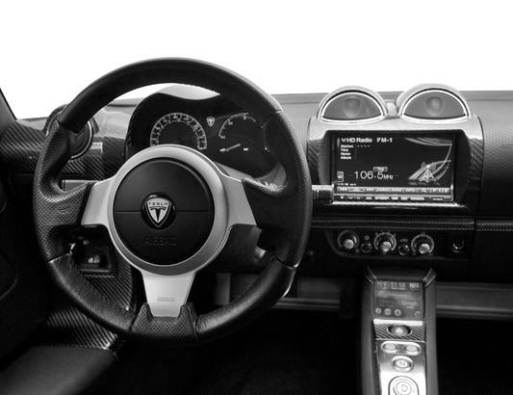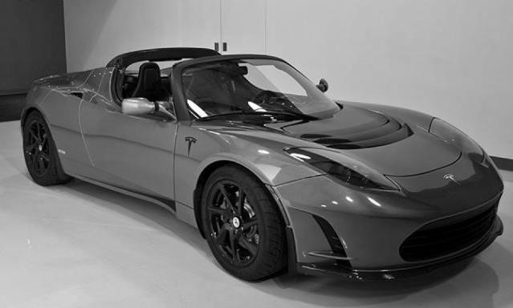

Fig. 2

-

Model appearance and dashboard of Tesla

Model S

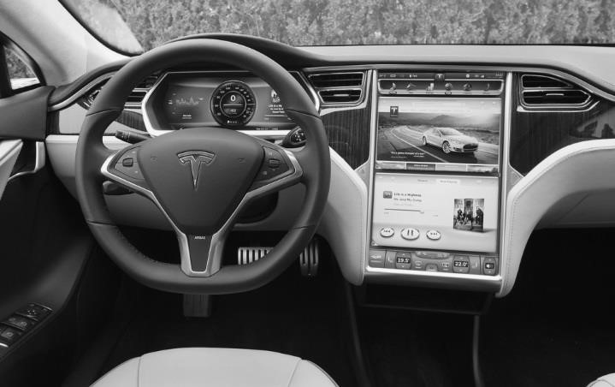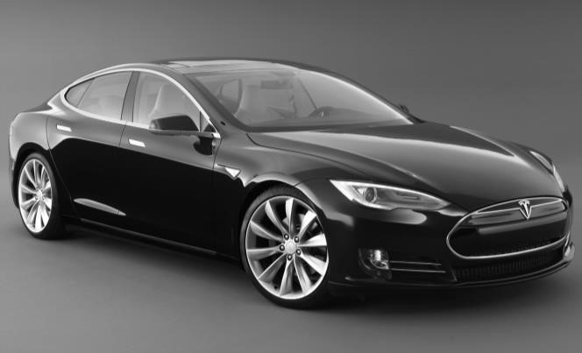

-

-

Fig.

3

-

The model appearance and dashboard of Tesla Model X

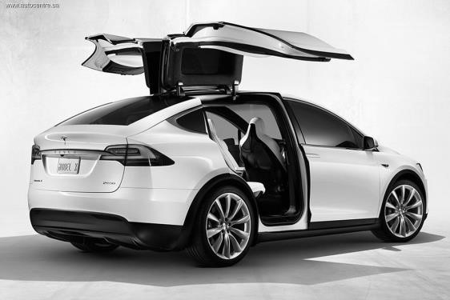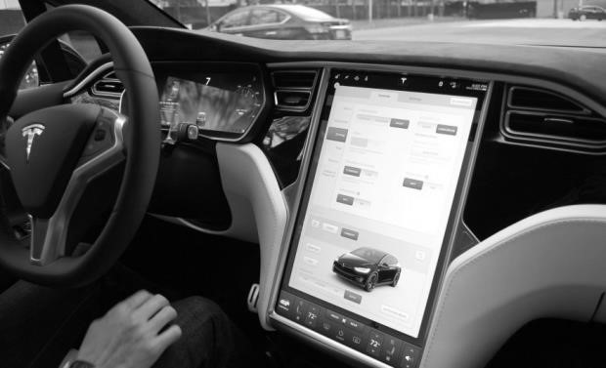

*CONCLUSION :*

The introduction of electric cars in our lives has become an urgent task in the light of the new agreement, worked out on the basis of the Climate Change Conference in Paris (December 2015) and endorsed by 196 of its participants, that actually binds the humanity to get away from fossil energy and develop technologies of obtaining and using energy from in-renewable sources.

This serious attitude to environmental issues contributes to the development of the car market with electric motors, which largely depends on the availability of infrastructure, price and public policy. In Ukraine, the joint project of OKKO charging network owners and Tesla Club Ukraine has become the most large scale project on creation of 34 free charging terminals for electric vehicles in 2014 on the busiest country highways. Tesla Motors plans to open two Supercharger stations of fast charging in Kiev and Lvov regions in 2016.

Unfortunately, the economy state of the country does not allow introducing incentives and compensation to owners of electric vehicles like in the developed European countries (Norway, Denmark, the Netherlands, Germany, France ...) and the United States. Nevertheless, the government abolished import duty for vehicles with electric motors, which reduced its price by 12% in November of last year. At present the law project on removal of VAT on the purchase of an electric vehicle is submitted to the Parliament, the adoption of which will reduce the price to 40%.

Having regard to the above and to the policy of Tesla Motors Company on creation of a low-cost vehicle, which presentation (Tesla Model 3) has to be held already in March, the increasing popularity and demand for Tesla brand electric cars in all the major cities around the world and in Ukraine is inevitable.